***1)Identify the exact location of Earth in the universe***

Earth is located within the Inner Solar System between Venus and Mars

***2)Describe the terms below as they relate to the solar system:***

***A) Universe***-The universe is all of space and time and their contents, including planets, stars, galaxies, and all other forms of matter and energy

***B) Stars***- a ball-shaped gaseous celestial body that shines by its own light

***C)Planets*-**A planet is a celestial body that (a) is in orbit around the Sun, (b) has sufficient mass for itself-gravity to overcome rigid body forces so that it assumes a hydrostatic equilibrium (nearly round) shape, and (c) has cleared the neighborhood around its orbit.

***D)Moon***- is a celestial body that makes an orbit around a planet

***E) Comet***- A celestial object that orbits the Sun along an elongated path. A comet that is not near the Sun consists only of a nucleus-a solid core of frozen water, frozen gasses, and dust. When a comet comes close to the Sun, its nucleus heats up and releases a gaseous coma that surrounds the nucleus.

***F) Asteroid***-Asteroids are actually minor planets which can neither be classified either as a planet or as a comet. These are generally in the direct orbit around the Sun, also known as the inner solar system. The larger forms of asteroids are also known as planetoids.

***3) Explain what is meant by the solar system while stating the order of the planets from the sun.***

The order of the planets in the solar system, starting nearest the sun and working outward is the following: Mercury, Venus, Earth, Mars, Jupiter, Saturn, Uranus, Neptune and then the possible Planet Nine

***B) Classify the planets and Jovian planets stay in orbit around the sun.***

Jovian planets include Jupiter, Saturn, Uranus, and Neptune. These planets have larger sizes and masses. Jovian planets do not have solid surfaces. They are sometimes called gas giants because they are large and made mostly of gasses.

***C) Explain how and why planets stay in orbit around the sun.***

The planets all formed from this spinning disk-shaped cloud, and continued this rotating course around the Sun after they were formed. The gravity of the Sun keeps the planets in their orbits. They stay in their orbits because there is no other force in the Solar System which can stop them.

***4)Discuss why we experience day and night***

This is because earth rotates on its own axis. This axis is an imaginary line that passes through the North Pole and South Pole of the earth. The sun is an enormous source of light and it does not move from its place as other planets revolve around the sun.

***5)Using diagrams, explain what happens during a lunar and solar eclipse***

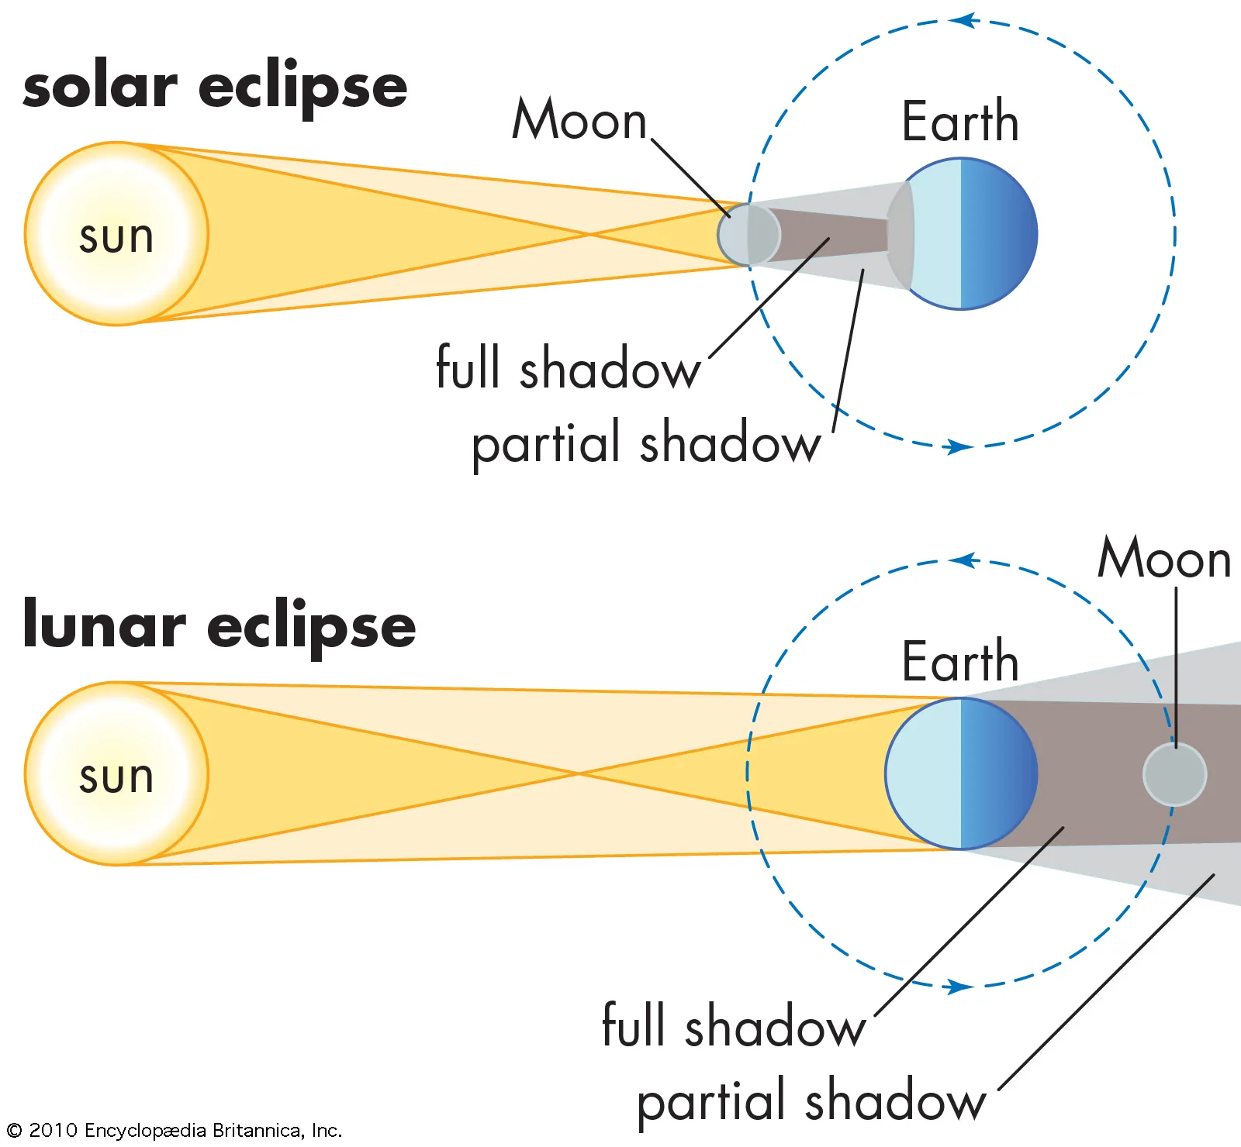

***6)Give four reasons for exploring the universe***

### ***A) Improving our day-day life***-Space technologies improve products we use every day, weather forecasts, and communications worldwide.

### ***B) Protecting our planet and our environment***-Space technologies improve products we use every day, weather forecasts, and communications worldwide.

***C)Improving Healthcare***-Experiments performed in space help us understand health problems on Earth.

***D)Making scientific discoveries***-Scientific breakthroughs are challenging our assumptions and pushing our boundaries by exploring the unknown.

**7)Distinguish between polar and geostationary satellites in terms of their direction of travel and uses**

Polar orbiting satellites provide imagery and atmospheric soundings of temperature and moisture data over the entire Earth. Geostationary satellites are in orbit 22,000 miles above the equator, spin at the same rate of the Earth and constantly focus on the same area.

***8)State the names of the country, dates and time of the first persons to set foot on the moon.***

***Country-***Soviet Union

***Dates-*** 21 July 1969

***Time-***02:56 GMT

***First Person-*** American astronaut Neil Armstrong

***9)In a table, give the year and name of the space stations launched by Nasa, Russia and the joint project between USA, Russia, Japan, Canada and Europe***

|  |  |  |
| --- | --- | --- |
| **Countries** | **Year** | **Name** |
| USA(NASA) | May 14th, 1973 | Skylab |
| Joint Project | November 20th, 1998 | International Space Station |
| Russia | February 21st, 1986 | Mir |

***10)Pictures showing flybys, orbiters and landers/rovers***

1. ***Flybys B) Orbiters***

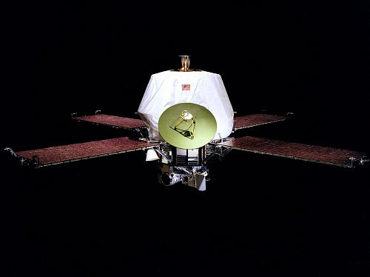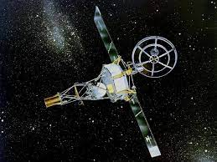

***C)Landers D) Rovers***

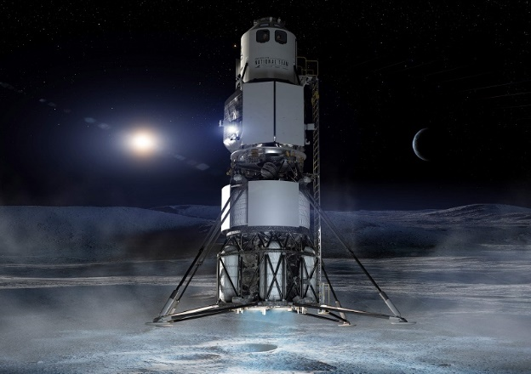

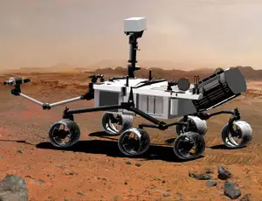

***11)What it means when an object is said to be in freefall.***

A free-falling object is an object that is falling under the sole influence of gravity. Any object that is being acted upon only by the force of gravity is said to be in a state of free fall.

**Name:** Daverelle Barry

**School:** St Rose Modern Secondary

**Form:** 5C

**Teacher:** Ms Pysadee

**Subject:** Integrated Science

**Topic:** Universe and Solar System

**Due Date:** 9th/09/2022

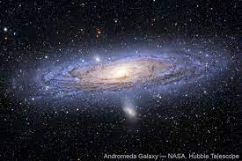

Table of Content

PAGE 1:

PAGE 2:

PAGE3:

PAGE 4:

PAGE 5: